Welcome to Big Brothers Big Sisters
of York & Adams Counties

Our vision is that all children achieve success in life.

Parent
Orientation Guide
6

Our mission is to provide children facing adversity with strong and enduring, professionally supported 1-to-1 relationships that change their lives for the better, forever.

We partner with parents/guardians, volunteers and others in the community
and hold ourselves accountable for each child in our program achieving:
  - Higher aspirations, greater confidence, and better relationships
  - Avoidance of risky behaviors
  - Educational success

This is what we do, this why we do it, and this is why it matters:
2014 percentage of youth maintaining or improving in our key areas:

 | Community | Site and School
Socio-Emotional Competence | 84% | 77%
Educational Success | 73% | 79%
Avoidance of Risky Behaviors | 67% | 75%

About Our Mentoring Programs
Big Brothers Big Sisters offers two primary mentoring programs: community-based, in which a Big and a Little spend time in the community doing activities; and site-based, where the Big visits with the Little at his or her school or another specified facility. You’ll discuss the options and the best choices for your schedule and for your Little’s needs early in the enrollment process. Here’s a brief overview of both.

Community Based Mentoring  Big Brother and Big Sister volunteers provide children and youth – our “Littles” individualized time and attention on a regular basis, typically 2 – 4 times a month, for two to three hours.  During unstructured weekly or bi weekly outings, filled with conversations and shared activities, they develop a relationship that helps youth manage the every- day challenges that are part of “growing up.”  During the time with their Big, children gain new skills, explore new interests and test behaviors that expand their experience base beyond their family or neighborhood. | Site-Based Mentoring  Volunteers offer children and youth individualized time and attention on a consistent basis, with the venue being the child’s school or other facility rather than out in the community. Teachers identify those children who can most benefit from an extra caring adult in their lives. Volunteers and children meet regularly during the school year – typically each week, utilizing the resources available within the school: computer labs, the library, the gym, a classroom, or the schoolyard. During the summer, they may exchange letters, email messages or phone calls, or attend an agency-sponsored event. Some matches enter a status called School-Based Plus which allows them to meet away from the school campus. And some matches move to become Community-Based Matches so they can meet more regularly.  Whether they play board games, or read the newspaper together, their relationship promotes a positive school experience for the child: good attendance, positive peer and adult relationships, a positive attitude, and academic enrichment. As their friendship evolves over time, volunteers and children discover ways to make school and learning fun. When matches continue from one school year to the next, volunteers experience the satisfaction of watching their Littles achieve success in school.

About Your Role
We need you to be an active Partner. Working together, parents or care givers, volunteers, and BBBS staff members plan activities and opportunities that can have a powerful and positive impact on your child. Here’s what you can expect to participate in as a partner in this match:
Talk with Match Support monthly. We will contact you monthly to get your point of view about the match, observations and questions. This monthly contact is required - it allows us to provide support, and offer ideas if problems arise. Note that for safety purposes, we will suspend or terminate any match where consistent conversation is not occurring.
Along with your child, participate in scheduled assessments and other requests, Big Brothers Big Sisters uses assessment date to recommend match direction, identify resources you may need, to evaluate the effectiveness of the program and of course, to ensure safety.
Know about each activity and give your approval in advance. When your child returns home from an activity with their Big, it’s very important that you talk openly with them about the activity. We’ll talk with you about your observations and conversations during our monthly conversations.
Call us! If you need help locating resources, are moving, have a joy to share, have safety concerns or need to talk about the match, call your Match Support Specialist.
Respect boundaries. We educate volunteers, families and Littles about the importance of focusing on what this match is and what it isn’t. For example, we ask all parents to remember that the Big is a volunteer and should not be asked to perform any services for the family, buy clothes or supplies, be asked to take siblings on outings, bring the child home to an empty house, and so on. We’ll look more at volunteer roles and responsibilities further on in this guide.
Follow all policies, procedures and ground-rules. Without exception, it is critical to safety and healthy relationship development that you adhere to our rules, as do our volunteers. We will discuss these during your training. Disregard or violation of policies and ground rules may result in immediate or discretionary suspension or termination of the match.
Support your child’s mentoring relationship. The time your child spends with his or her Big can be an invaluable experience so sticking to scheduled times, getting to know the Big, talking with your child about the experience and promoting the activities and events offered by the agency are great ways to partner.

About Safety
The safety of your child is our number one priority – no exceptions. While our staff carefully screens each volunteer, we need your help to make sure the relationship is healthy and the volunteer is making good judgments about your child’s safety on outings. Here’s how you can further promote safety:
- Participate in planning and approve activities; if you are not comfortable with an activity that your Big suggests, you are encouraged to not approve. Talk to your BBBS match support staff when you have questions.
- When your Big takes your child out, the Big should always stay with him or her and not leave them alone or with someone else.
- Your child’s Big should not use alcohol or other drugs or tobacco before or during activities with you child.
- Your child’s Big should not use physical discipline or yell at your child.
- If an activity involves changing clothes to go swimming, there should be separate changing and showering places.
- Volunteers should never ask a child to keep a secret.
- Volunteers might want to buy an occasional gift for your child. They should ask your advice about this first.
- Volunteers should not engage in tickling, wrestling, giving backrubs, or asking a child to sit on their lap.
- Seatbelts should always be worn.
- Bigs should never drop off your child at a home where no approved adults are present or at a location other than where you specified.
- Showing age-inappropriate videos, misusing social media, pornography or sexual material is not acceptable and is grounds for match termination. Speak with the Big and the Match Support Specialist right away if you see or suspect any of these activities are occurring.

Disregard or violation of ground rules may result in immediate or discretionary suspension or termination of the match
Here are some patterns that you should discuss with your Match Support Specialist:
- Your child’s Big wants to spend more and more time with your child.
- Your child’s Big often invites other children to join them in activities (siblings, child’s friends, etc.).
- Activities always take place in private settings such as a volunteer’s home, camping setting - instead of more public settings.
- Your child’s Big takes an excessive number of pictures or videos of your child.
- The Big becomes involved with your family, buys gifts for your child or provides services beyond the scope of this program.

We know that you work with your child to teach them skills to help keep them safe from violence – whether it’s online, at school, at home and in your community. Please feel free to discuss these issues and any other issues related to child safety with your BBBS Match Support Staff. We want to work with you to keep your child safe.
Required reporting of child abuse and neglect

Big Brothers Big Sisters staff members are required to report any suspected abuse or neglect of a child. Our staff and volunteers are trained to respond if a child tells them about abuse. A report will be filed with Pennsylvania Child Line and authorities.
If you have any further questions or would like more information on violence prevention, please don’t hesitate to ask our staff for additional resources.
If at any time you suspect that your child is being harmed, either within our program or elsewhere, please contact Big Brothers Big Sisters’ staff.

About Match Activities and Goals
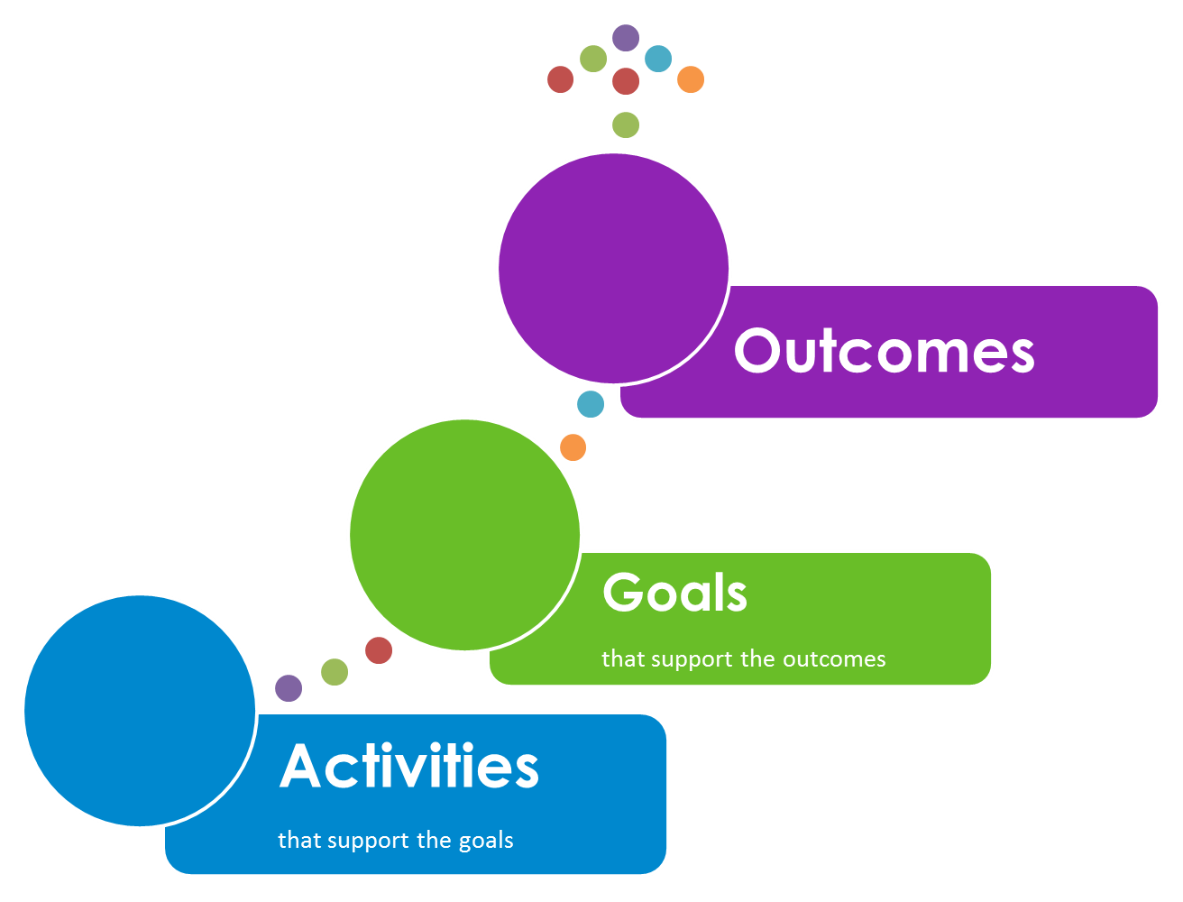

Being in a match is about both having fun and achieving positive outcomes. Your Match Support Specialist will work with you, the Big and your child (teachers, too, if it is a school-based program) to identify goals for the match, which will likely fall into one or more of these three categories of:
- Avoidance of risky behaviors
- Educational Success
- Higher aspirations, greater confidence, and better relationships

When you discuss goals with your Match Support Specialist, they will fall into one or more of these categories. These categories represent the most common youth outcomes found as a result of effective mentoring. In general, youth-specific match goals are established to produce one or more of the youth outcomes. The activities your child participates in should support those goals, which can produce the desired outcomes.
About Our Bigs
Based on years of extensive research, Big Brothers Big Sisters requires our volunteers to be capable of the following commitments. Our professional staff work with volunteers to ensure these commitments can be met by providing coaching, training and activities to help you develop in your role as a Big.
- Commit to a minimum of 12 months as a Big.
- Commit to spending consistent, significant time with their Little each month.
- Follow all agency policies, procedures and ground rules. Because child safety is a top priority, we consider violations of policies, procedures, and ground rules to be grounds for match suspension or termination.
- Maintain regular communication with Match Support staff, including returning all calls and emails. Failure to maintain contact may result in closure of the match.
- Participate in required surveys and assessments related to the match relationship and youth outcomes.
- Complete assigned training.

Research tells us that Littles achieve greater results when their Big….
- Emphasizes friendship over changing the behavior.
And we know what a Big is not:
ATM
Childcare provider
Provider of professional services
Tutor (although sometimes school-related activities are part of your time together)
We will work with you to ensure healthy boundaries are established and respected by everyone.

- Is not authoritarian.
- Decides activities together with Littles.
- Is consistent & dependable.
- Has realistic expectations about the Little.
- Is patient.
- Focuses on having fun.
- Sets boundaries and limits.
- Acknowledges that positive impact on the child comes after the relationship is built.
- Puts a child’s safety and well-being first.
- Helps form goals.

About the Enrollment Process
Potential Littles, along with their families, are screened to ensure that our mentoring programs are the best fit for the Littles needs. The process for children and their families looks like this:
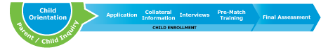
Enrollment Steps
- Inquiring about being a Little
- Orientation to Big Brothers Big Sisters programs
- Completing the application
- Providing collateral information
- Interviewing with us
- Participating in Pre-Match Training

Leading the enrollment and matching processes are professionals whose job it is to make the best possible match. When a match is made, a Match Support Specialist oversees the relationship by providing coaching, ensuring safety, assisting in goal-oriented activities, referring services, and helping you, the Little and his/her Big. It is therefore critical for all match parties to treat contact by the Match Support Specialist as a serious component of match development. Lack of response to Match Support’s contacts is grounds for match suspension or termination, which can have detrimental impact on the Little.
Later in the process, you’ll receive training and instruction on our policies, procedures and guidelines – all of which are designed to help you have the most positive impact on a Little as possible.

The enrollment process for our volunteers is similar to the process you will complete and looks like this:
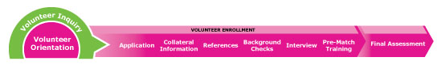
In addition, potential volunteers also go through intensive background checks, home visits, interviews with partner/spouse and others in the household.
These initial enrollment processes, along with Match Support, policy and procedure adherence by all, are critical components of our safety system.
Big Brothers Big Sisters retains the right to accept or deny participants, or close a match
at any time.
About Expectations
If your child is approved and enrolled, you can expect a structured, professional process. Here’s how it works:
- Match Introduction Meeting: Is a time that you, your little and your Big are introduced by staff usually taking place in the child’s home. Match introduction paperwork is signed and a review of the ground rules as well as exchange of information is completed.
- Communication with Match Support staff (phone, e-mail, and in-person as needed): Program support team will contact you 48 to 72 hours after your match introduction takes place and will answer any questions that you have. Next contact will take place two weeks after the match introduction so your child is able to have some time with his/her Big and will be able to refer any questions resulting from that with program support. Following contact will be made monthly to review activities, set and update any goals, answer any questions and provide directions that may be challenging for the match. Over all ensuring safety of the match.
- Post-Match training: Any training requested by you will be provided by program support staff as needed. Continuous guidance and suggestions will be provided by program support on an ongoing basis throughout the match relationship by program staff through match support contacts.
- Match activities and events: Program support will provide volunteers with all information regarding match activities through email, mail or phone calls
- Youth Development Plan participation: Youth development plan will initially be set and approved by you and staff. Throughout the match all match parties will work collectively to review and report success to the agency
- Annual survey completion: Annually each match party (volunteer, child and parent) will be asked to provide feedback to the program support team reflecting the status of the match to provide the child with the best, safe one to one mentoring experience.

About Match Closure
We know from research on mentoring that when relationship closure is unplanned, abrupt, premature, or handled without care and communication, Littles can be harmed. In addition, mentors may also be left feeling guilty, sad, or lacking closure.

It may seem odd or even pessimistic to discuss this stage when your child is contemplating or entering a mentoring relationship. However, research shows that when mentors, parents and children are trained in how to handle match closure well and, in partnership with Match Support staff, actively plan for the end of their match, it can be a positive process that allows for reflection and personal growth for both the mentor and the Little.

At the time of closure, Big Brothers Big Sisters will discuss with you, your Little, and the Big (and teacher) about the best plan for closing your match relationship with the organization. When a match is closed, Big Brothers Big Sisters officially closes the file and does not continue to provide professional support or guidance to the previously matched parties. At that point, the match is no longer considered an “active” match, or part of the Big Brothers Big Sisters program. This means that Big Brothers Big Sisters is no longer responsible for or involved in the relationship.

By this time, your child and his or her Big have most likely invested a lot into each other and the relationship. During the closure process, it is important that Bigs and Littles celebrate their time together and set plans for the future
When your match closes, talk to your Match Support staff about ways in which you can stay involved with Big Brothers Big Sisters. This may include your child being matched again, but there are many other ways in which you can be involved with the agency. You and your Match Support staff should talk about the best options for you.
About Our Families
About Our Non-Discrimination Policies:

Children are not excluded on the basis of race, religion, national origin, color, gender, marital status of parent, sexual orientation, gender identity, veteran status or disability.

Volunteer Big Brothers, Big Sisters, Board Members, and Agency Staff as Volunteer Bigs are not excluded on the basis of race, religion, national origin, color, gender, marital status, sexual orientation, gender identity, veteran status, or disability.

Type of Primary caregivers of our Littles:
73 % Single parent / guardian
24 % Two parent / Guardians
3 % Out-of-home care
Common languages spoken in homes of our Littles:
English is the most common language spoken in the homes of children we serve
Socioeconomic status (SES) of our families:
BBBS of York & Adams Counties serves families across all socioeconomic statuses, but 72.9% live at or below 200% of poverty
Current number of matches:
Our Community-based Program has over 60 matches and our SMART Program, our school based program, currently supervises approximately 250 kids between York and Adams Counties
Average length of match:
The average length of our matches is 18 months
Goal for number of new matches this year:
Our current goal is 25 new matches

Average Age of Littles:
We serve mostly children ages 8-12
Age range:
Children ages 6 to 13
Race/Ethnicity:
BBBS of York & Adams Counties serves children of any race/ethnicity, giving us a diverse range of participants
Gender: 55% male
45% female

Neighborhoods:
Children served by BBBS of York and Adams Counties are located throughout schools and communities in York and Adams Counties.
Number of Littles currently on waiting list:
There are currently 45 children on our waiting list

About Big Brothers Big Sisters of York & Adams Counties
Agency Name: Big Brothers Big Sisters of York & Adams Counties
Agency Address: 227 W. Market St, Suite 102 York, PA 17401
18 Carlisle St, Suite 109, Gettysburg, PA 17325
Phone number: (717) 843-0051
Website: www.bbbsyorkadams.org

Additional Questions or Child Safety Concerns
Executive Director: Linda Gorter
Phone number: (717) 843-0051 x 101
Email Address: lgorter@bbbsyorkadams.org

Local child services: York County Children & Youth Services:
Phone Number: (717) 846-8496 or 1-800-729-9227
Adams County Children & Youth Services:
Phone Number: 717-337-0110
PA Child Line and Abuse Registry: 800-932-0313

Please make note of Questions / Comments so we can serve you better.

